Design Patterns and Principles
Ex – 1: Singleton Pattern
import java.util.*;
class Logger {
private static Logger instance;
private Logger() {
System.out.println("Instance created");
}
public static Logger getInstance() {
if (instance == null) {
instance = new Logger();
}
return instance;
}
public void log(String message) {
System.out.println(message);
}
}
public class Main {
public static void main(String[] args) {
Logger logger1 = Logger.getInstance();
Logger logger2 = Logger.getInstance();
logger1.log("Application Started");
logger2.log("Loading Modules");
System.out.println("logger1 hashCode: " + logger1.hashCode());
System.out.println("logger2 hashCode: " + logger2.hashCode());
System.out.println("Same object? " + (logger1 == logger2));
}
}
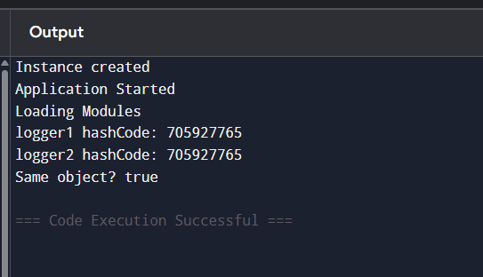

Ex – 2: Factory Method
interface Document {
void open();
}
class WordDocument implements Document {
public void open() {
System.out.println("Opening Word Document");
}
}
class PdfDocument implements Document {
public void open() {
System.out.println("Opening PDF Document");
}
}
class ExcelDocument implements Document {
public void open() {
System.out.println("Opening Excel Document");
}
}
abstract class DocumentFactory {
public abstract Document createDocument();
}
class WordFactory extends DocumentFactory {
public Document createDocument() {
return new WordDocument();
}
}
class PdfFactory extends DocumentFactory {
public Document createDocument() {
return new PdfDocument();
}
}
class ExcelFactory extends DocumentFactory {
public Document createDocument() {
return new ExcelDocument();
}
}
public class Main {
public static void main(String[] args) {
DocumentFactory wordFactory = new WordFactory();
Document word = wordFactory.createDocument();
word.open();
DocumentFactory pdfFactory = new PdfFactory();
Document pdf = pdfFactory.createDocument();
pdf.open();
DocumentFactory excelFactory = new ExcelFactory();
Document excel = excelFactory.createDocument();
excel.open();
}
}
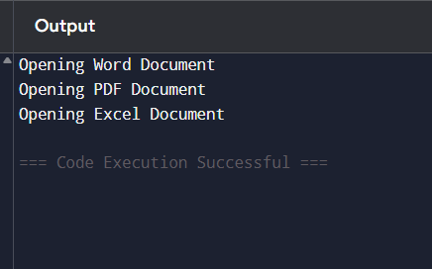

Ex-3: Builder Pattern
class Computer {
private String cpu;
private String ram;
private String storage;
private Computer(Builder builder) {
this.cpu = builder.cpu;
this.ram = builder.ram;
this.storage = builder.storage;
}
public void showSpecs() {
System.out.println("CPU: " + cpu);
System.out.println("RAM: " + ram);
System.out.println("Storage: " + storage);
System.out.println();
}
public static class Builder {
private String cpu;
private String ram;
private String storage;
public Builder setCPU(String cpu) {
this.cpu = cpu;
return this;
}
public Builder setRAM(String ram) {
this.ram = ram;
return this;
}
public Builder setStorage(String storage) {
this.storage = storage;
return this;
}
public Computer build() {
return new Computer(this);
}
}
}
public class Main {
public static void main(String[] args) {
Computer gamingPC = new Computer.Builder()
.setCPU("Intel i9")
.setRAM("32GB")
.setStorage("1TB SSD")
.build();
Computer officePC = new Computer.Builder()
.setCPU("Intel i5")
.setRAM("8GB")
.setStorage("512GB SSD")
.build();
System.out.println("Gaming PC:");
gamingPC.showSpecs();
System.out.println("Office PC:");
officePC.showSpecs();
}
}
